

Software Quality Assurance

Assignment 1

By Ayesha Wajid (22-10070)

The report contains screenshots of the Test Cases, Testing Suite and the Module which shows the Tests ran successfully.

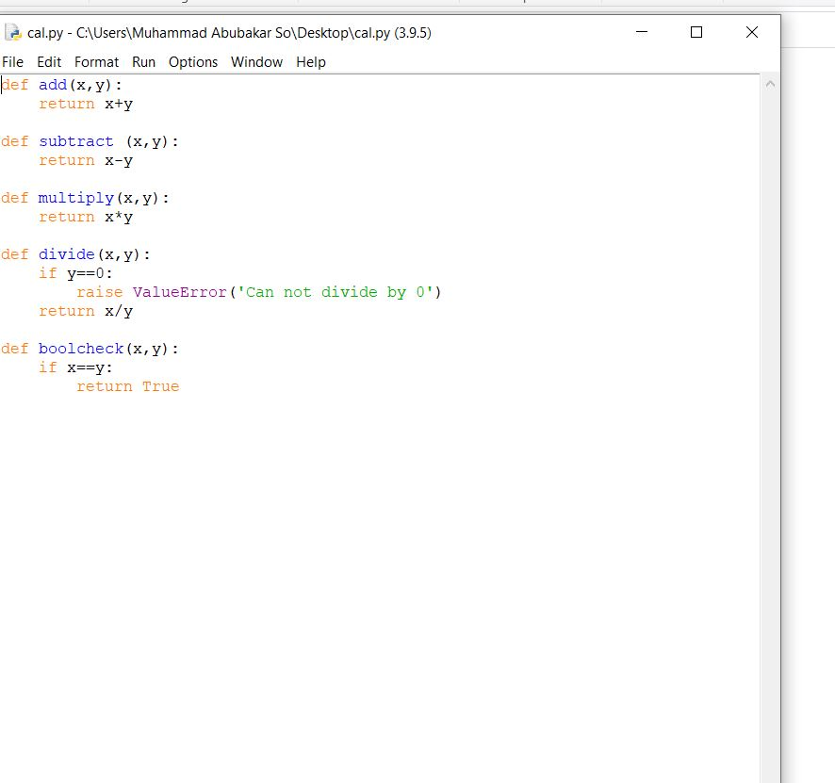

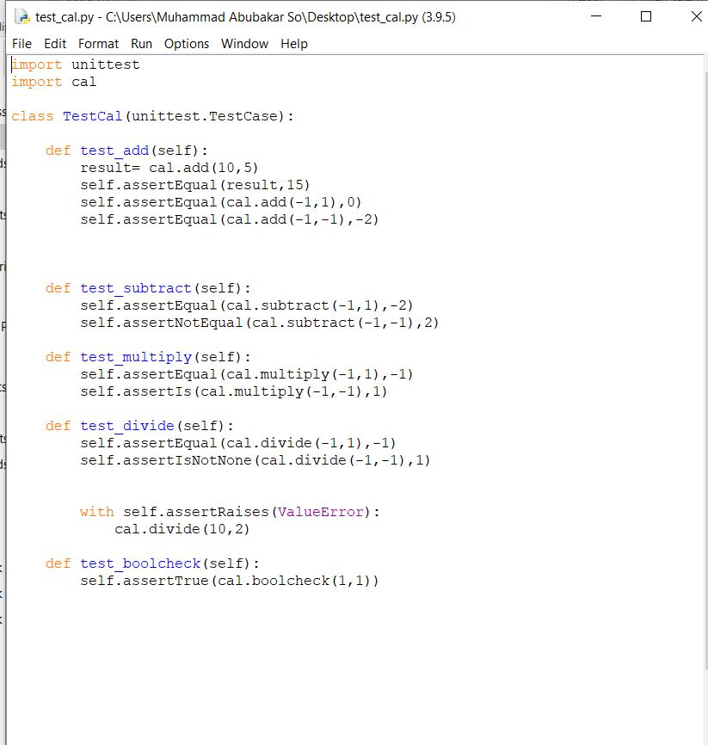

Shows the file to be tested

Shows the testing cases

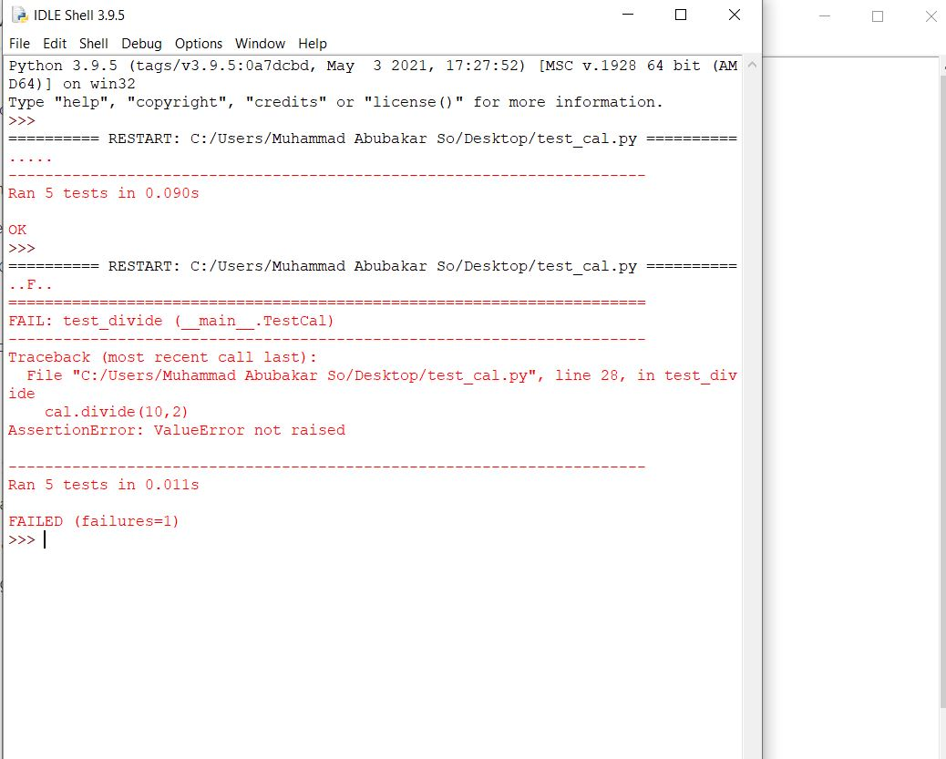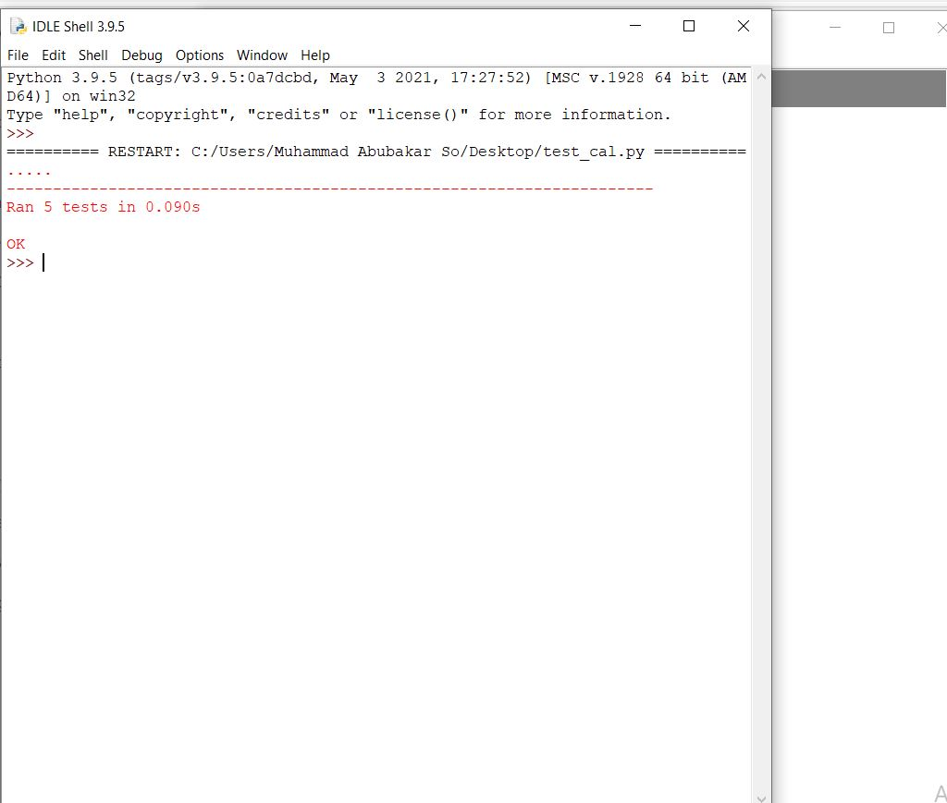**These two pictures show the test running successfully and when values are changed the errors.**